**MSK Cluster Hands-on**

**Create 3 Subnets and attach them to VPC**

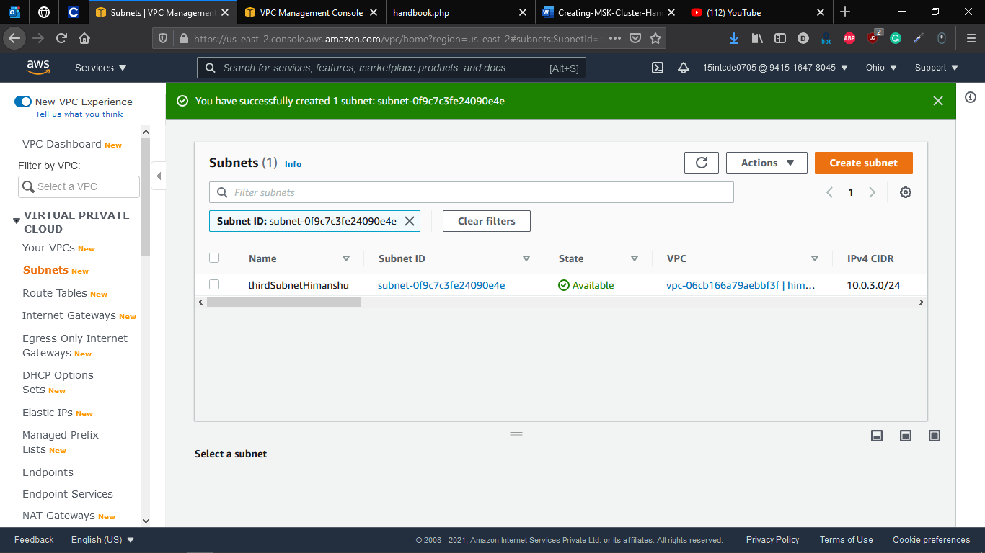

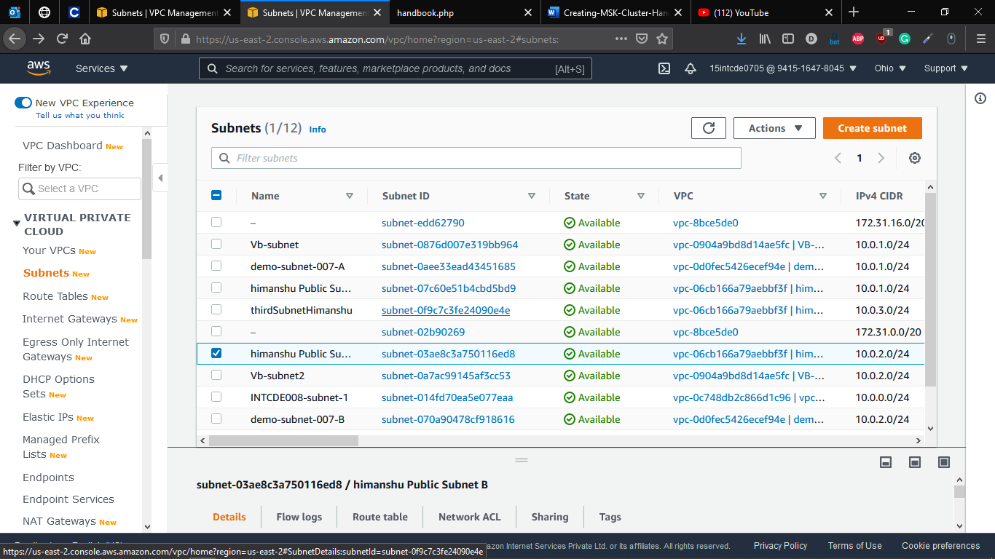

**Create New MSK Cluster**

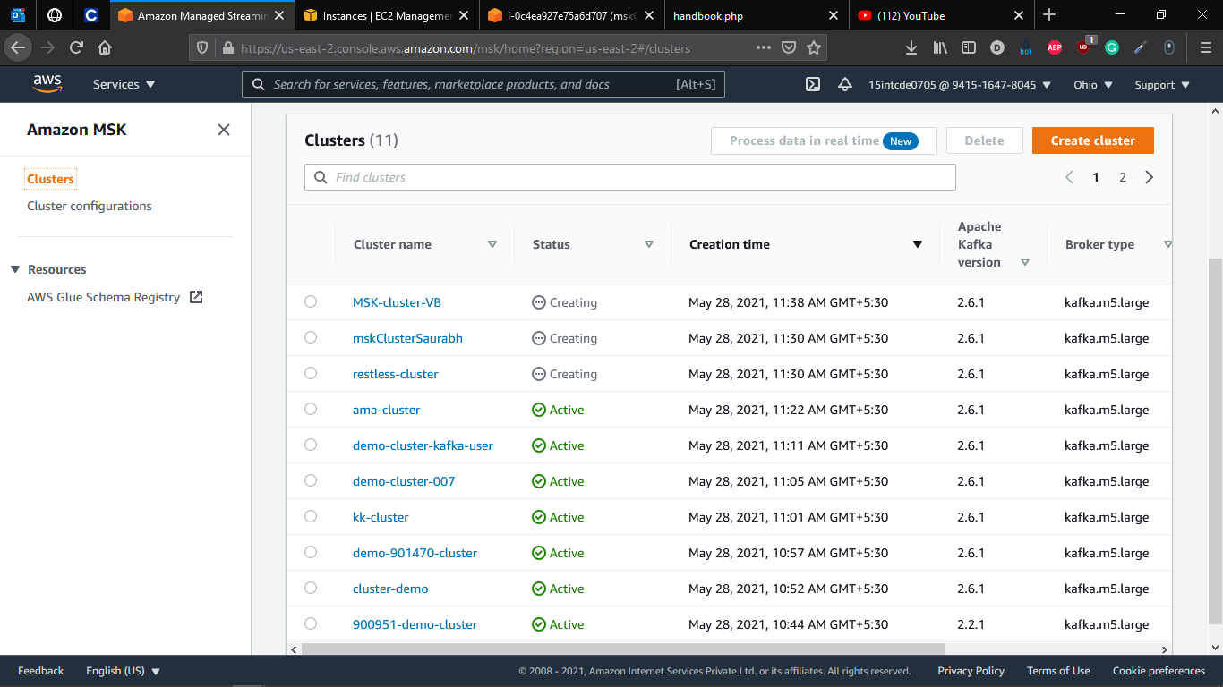

**Creating New IAM role to connect to cluster**

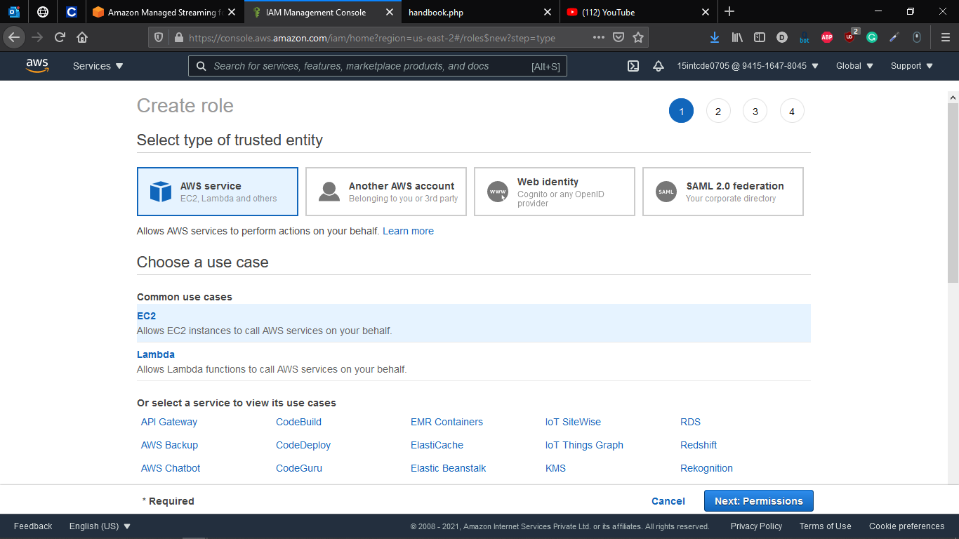

**Giving Cluster Access Permission to role created**

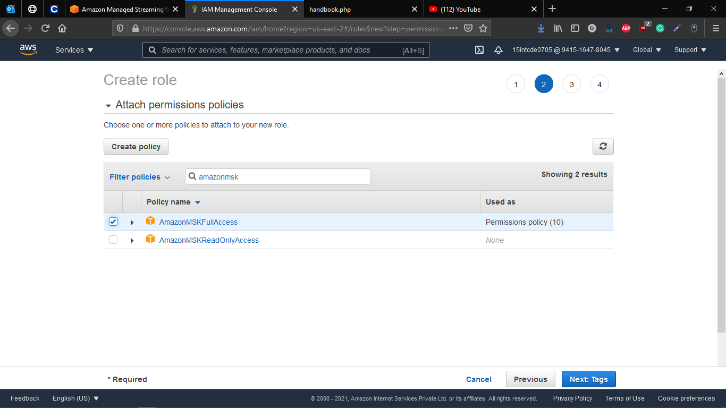

**New Role Created**

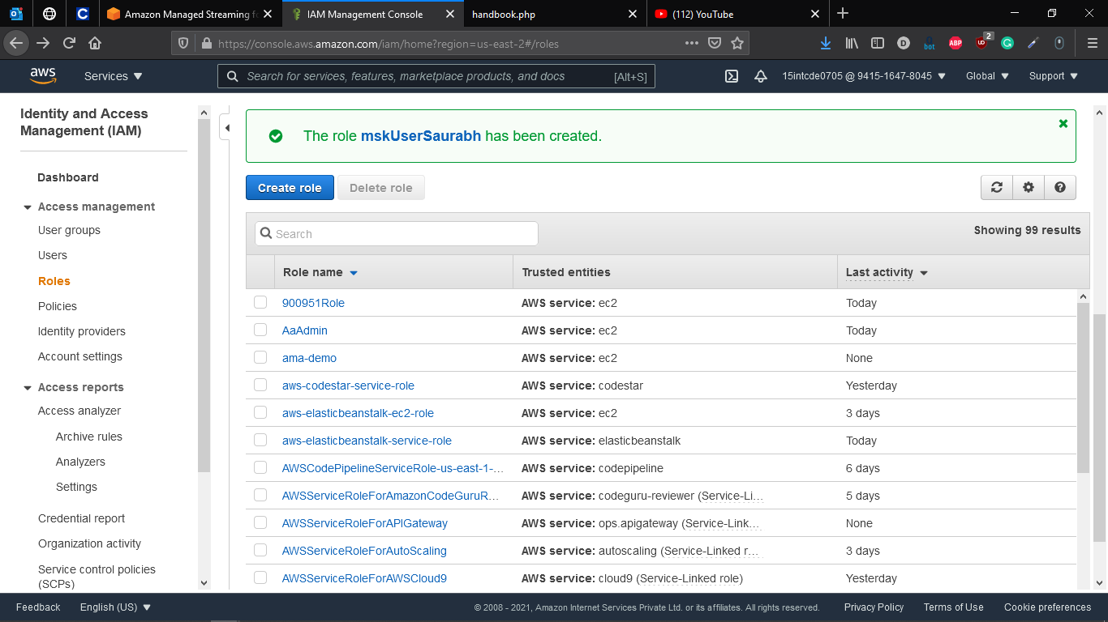

**Running Cluster**

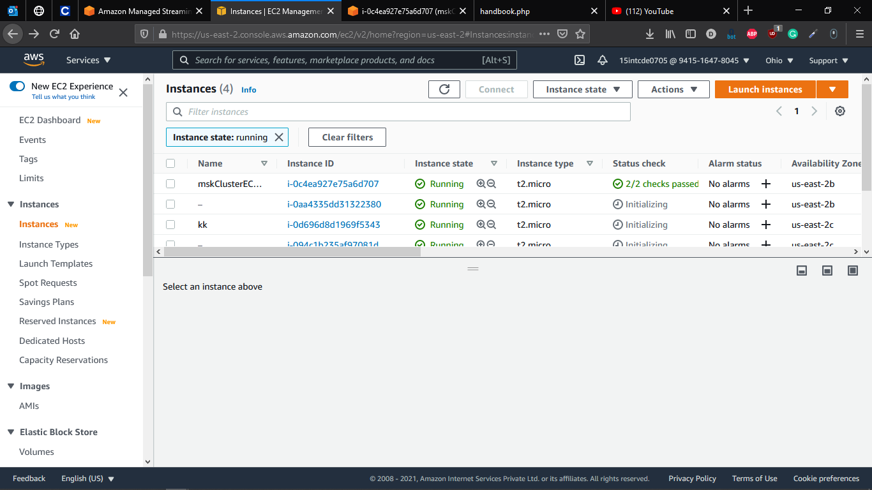

**Connect to EC2 Cluster**

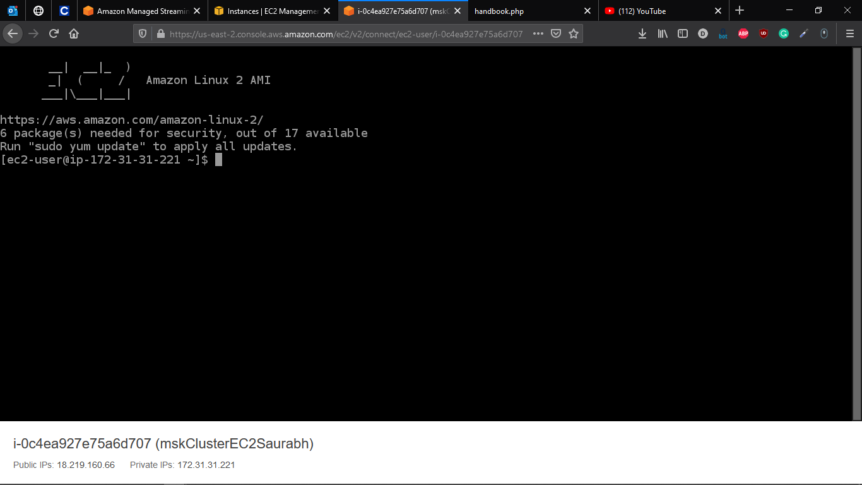

**Run Command – “**aws kafka list-clusters --region us-east-2**”**

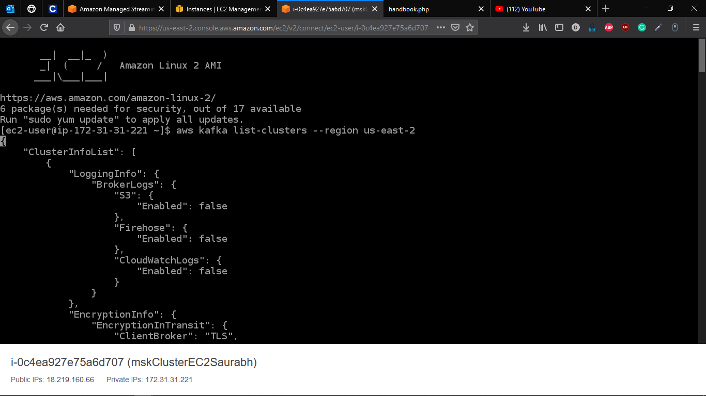

**To Connect to our created Cluster Copy Cluster arn**

Command -

aws kafka describe-cluster --cluster-arn arn:aws:kafka:us-east-2:941516478045:cluster/kk-cluster/16162344-7c1e-4c8a-813e-32e867599462-3 --region us-east-2

